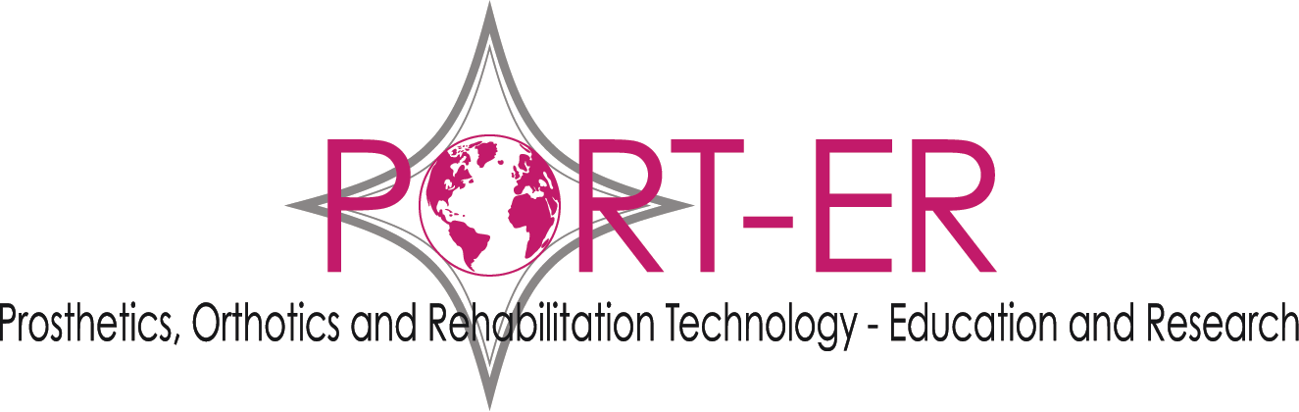
PORT-ER Notes for grant applicants 2018
Theme for 2018: User engagement and participation in prosthetics and orthotics developments.
Closing Deadline 5pm GMT Sunday 4 March 2018.
Micro grants £25 - £250.
Professionals and organisations: Our 2018 grant round is about encouraging professionals, services and designers to include prosthetics and orthotics service users in planning, improving or evaluation of developments (services, activities, support, advocacy or products).
Users: Our 2018 grants will also support prosthetic or orthotic user group meetings or social activities. Or perhaps a special meeting is called by an organisation locally, but you are an individual user having to fund your own engagement in that meeting. We would like to help you with that.
This year we are offering “mustard seed” micro grants ranging from £25 to £250. We hope that this will help to encourage small ideas and actions to grow – or simply help users to contribute to bigger projects. Sometimes development is hard to achieve without small costs for local travel or coffee being covered.
Applications are welcomed from the UK and any country. We would like to make at least one UK award. Other awards could be UK and/or international. Our application process is simple – we just need enough information from applicants so that we can make a decision! Please complete and submit an application form having read these Notes to Applicants.
Please visit our projects page to see our history of grant funding. http://port-er.com/projects/.
Grant Funding is available to applicants annually from PORT-ER subject to sufficient funds being available. The annual grant round will be announced each year on the PORT-ER website.
Grant applications will be judged by the Board of Trustees of PORT-ER in relation to how well they are able to meet the aims of the charity:
- to encourage safe standards of prosthetic and orthotic care to internationally recognised standards;
- to support the advancement of knowledge in prosthetics and orthotics by sharing information;
- to support innovation in prosthetics and orthotics.
- to provide funding to communities of patients/users to enhance patient/user education. (Note this must be users of external prosthetic limbs and/or users of orthoses for the limbs or spine).
Grants are normally awarded to a group or organisation in any country but may be awarded to individuals in the UK. Please note we do not offer grants to attend international conferences.
Downloads are available at http://port-er.com/grants/
- Download PORT-ER Notes for grant applicants 2018
- Download PORT-ER Grant Application form 2018

Applications will be accepted until 5pm GMT on Sunday 4 March 2018.

Applications are required to be:
- on the PORT-ER Grant Application Form 2018
- written in plain English
- written so that it can be understood by a lay person
- saved in the format ApplicantName_PORT-ER_grant_application_2018.
- completed and sent as an email attachment to Mrs Sandra Sexton, Chair of Trustees, PORT-ER to sandy@port-er.com. Paper copy submissions are not acceptable.
- Applications will be accepted until 5pm GMT on Sunday 4 March 2018.
Any grant application that employs research methods involving the use of human subjects must ensure that ethical approval is sought from the relevant national authority. PORT-ER will ensure that all research/educational applications are subject to peer review and decisions about research applications may take longer.
The theme of the PORT-ER 2018 grant round is “User engagement and participation in prosthetics and orthotics developments”.
Our grant round opens on Sunday 4 February 2018 and closes at 5pm GMT on Sunday 4 March 2018.
We are a small charity. In 2018 please do not request grants for more than £250. Trustees will review applications in March 2018. Applicants will be informed of the outcome of their application by Friday 27 April 2018.
No further open applications will be accepted out with this deadline or until the 2018 grant round (to be announced on the webpage http://port-er.com/grants/ in 2018). To receive an alert about grants by email and other news from PORT-ER, please go to our home page and fill in your email address in the newsletter request box.
The decision of the Board of Trustees is final.
A condition of grant funding is that successful applicants will provide a short report and photograph to PORT-ER at the time of completion of the project, showing how the grant was used and the outcome. (One paragraph of the project for micro grants. One page for other grants). This will then be placed on the PORT-ER website. (It is your responsibility to ensure relevant permission is obtained for any photographs).
Previous grant recipients are welcome to apply.
In 2017 we had 4 grant applications in our grant round. 3 of these were awarded and 1 was rejected.
Downloads are available at http://port-er.com/grants/
Download PORT-ER Notes for grant applicants 2018
Download PORT-ER Grant Application form 2018

About PORT-ER
PORT-ER is the charity where mobility matters. Our vision is to bring about better patient care for people with mobility challenges through national and international development. We are a small UK based charity and we raise funds to be able to award small grants depending on our resources in an annual grant round to groups or individuals who need funding for project activities that align with our aims.
Our aims are:
- to encourage safe standards of prosthetic and orthotic care to internationally recognised standards;
- to support the advancement of knowledge in prosthetics and orthotics by sharing information;
- to support innovation in prosthetics and orthotics .
- to provide funding to communities of patients/users to enhance patient/user education.

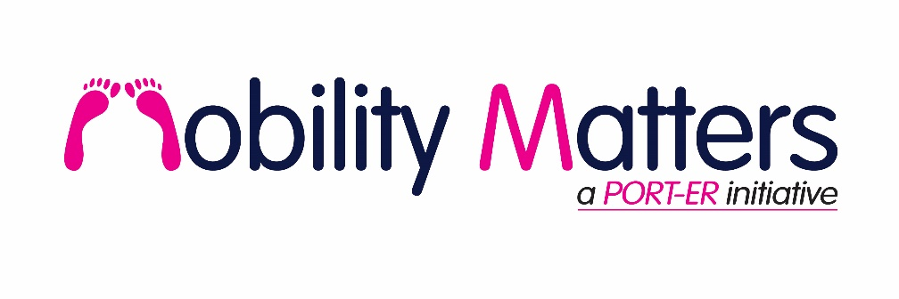
Mobility is a human right. Prosthetic limbs and orthotic braces are assistive technologies which enable people with physical disabilities to be more mobile. In turn, mobility can help those with limb amputations or dysfunctional limbs to access education, work, activities of daily living, and a social life (including sport).
The mobility needs of people in the UK and the mobility needs of people in developing countries are equally important. We believe that people with physical disabilities have the right to achieve all they can be in the context of their own environment. We provide grant funding so that we can respond to the needs expressed to us via grant applications from prosthetic or orthotic users, other charities or rehabilitation professionals, rather than all our activity being only trustee driven.

